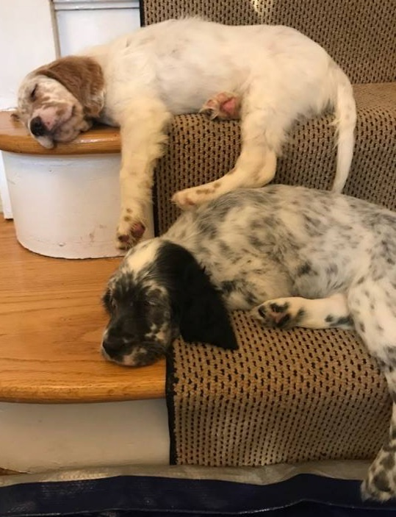

Let’s Step it Up in 2025.

You can make the raffle for this year, extra special, by providing donations.

All donations welcome---
large or small

Please help make our raffle table overflow with your generosity, so everyone can have a chance of taking something out.

There are three easy ways to donate:
- Bring your raffle donation directly to the National.
- Mail your donation to: Charnell Bolger: 13937 15th Place SW, Burien WA 98166
- Donate through Stripe using the link on the National website: http://national.esaa.com
Our raffle committee will be using the funds to purchase items for the raffle.

Please send an email to 2025ESAAnationalraffle@gmail.com to let us know of your donation so we can list your name and donation in our ESAA catalog and newsletter

Raffle Committee Members:

- Chairperson – Tracy Wiles
- Member – Kathy Cunningham-Roy
- Member – Melissa Hunt
- Member – Kendall Moore
- Member – Linda Romatko
- Media Coordinators – Monique Altomonte & Kendall Moore

All Donors will be listed on the national.esaa.com website under the Raffle tab and they will be included in the catalog.

